1. What does an empty dictionary’s code look like?

**Answer:**

{ } (open and close curly brackets)

2. What is the value of a dictionary value with the key ‘foo’ and the value 42?

**Answer:**

{‘foo’:42}

3. What is the most significant distinction between a dictionary and a list?

**Answer:**

The most significant distinction between dictionary and list is : the items in the list are in ordered form while items in dictionary are unordered.

4. What happens if you try to access spam[‘foo’] if spam is {‘bar’: 100}?

**Answer:**

You’ll get a KeyError error.

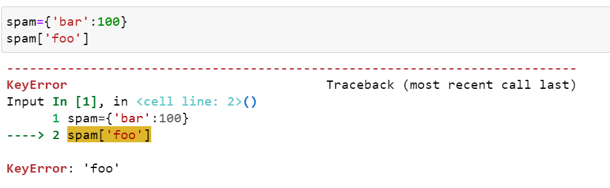

5. If a dictionary is stored in spam, what is the difference between the expressions ‘cat’ in spam and

‘cat’ in spam.keys()?

**Answer:**

There is no difference. Both checks whether there is a ‘cat’ key exists in the dictionary.

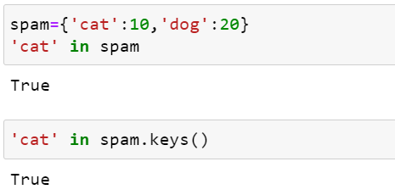

6. If a dictionary is stored in spam, what is the difference between the expressions ‘cat’ in spam and ‘cat’ in spam.values()?

**Answer:**

The expression ‘cat’ in spam will check if the ‘cat’ key is present in the dictionary. And the expression spam.values() will check if ‘cat’ is stored as a value for one of the keys in dictionary.

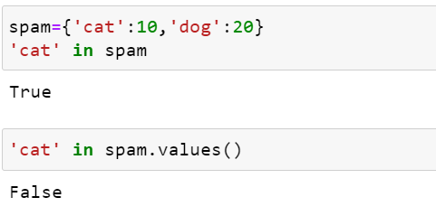

7. What is a shortcut for the following code?

if ‘color’ not in spam:

spam[‘color’] = ‘black’

**Answer:**

Spam.setdefault[‘color’,’black’]

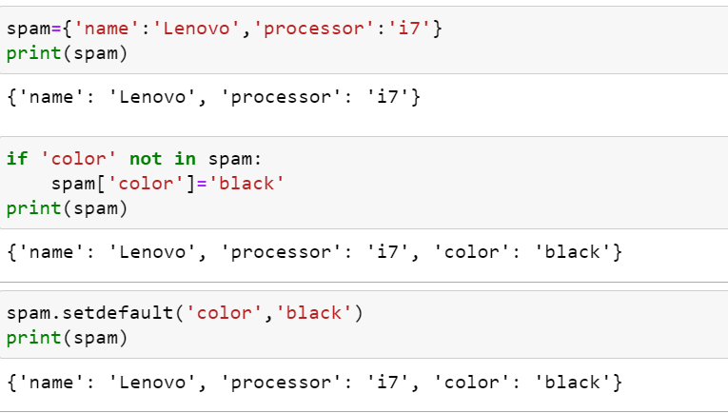

8. How do you “pretty print” dictionary values using which module and function?

**Answer:**

pprint is the module used to pretty print the dictionary. Within the module pprint() function is used to pretty print the object/strings.

pprint.pprint()

